**1. Introduction**

**Incidents** are just unplanned events of any kind that disrupt or reduce the quality of service (or threaten to do so). A business application going down is an incident. An incident tracking system is a software mechanism that allows an enterprise to record and follow the progress of every problem that a computer system user identifies until the problem is resolved. Some organizations employ Computer Security Incident Response Teams to investigate and respond to security incidents. Save your company valuable time and money with the only incident tracking mechanism that allows users to generate their own incident types instantly. When an incident ticket is opened, it can be tied to a related problem ticket. Once the problem ticket has been resolved and closed, related incident tickets close as well - automatically.  For superior tracking, the mechanism offers live incident reports and notifications that allow you to monitor issues in real time. The incidents can be recorded in archives, so that they can be analyzed in the future. Resolving a problemmeans fixing the error that will stop these incidents from occurring in the future. The incident data can be exported to Excel. The user-friendly mechanism will allow you to stay on top of any issues, so you can improve safety systems, decrease risks, enhance employee performance, and contribute to a healthier, more profitable work environment.

**Organization of report:**

Chapter 1: In this chapter a brief Introduction about the introduction is mentioned.

Chapter 2: In this chapter a System Analysis- proposed system, problem statement, project objectives and feasibility study have been mentioned.

Chapter 3: In this chapter, System requirements and system design through UML diagrams and implementation of project are mentioned.

Chapter 4: In this chapter, Implementation the current project is described.

Chapter 5: In this chapter, Code Analysis of the project is implemented.

Chapter 6: In this chapter experimental results obtained are provided.

Chapter 7: In this chapter project is concluded.

**2. SYSTEM ANALYSIS**

System Analysis is the first stage according to System Development Life Cycle model. This System Analysis is a process that states with the analyst. Analysis is a detailed study of various operations performed by a system and their relationship within and outside the system.

**2.1 Proposed System**

Business always targets for uninterrupted services to accomplish greater proficiency and productivity. Incident management is the initial step embraced by most enterprises for achieving speed recovery. When an incident occurs, the major goal of the management is to get the service restored to a normal level of operation within agreed service level agreements. It is the main component of service support. Though certain operations fail to resolve or configure to normal operations, yet they are considered as an incident. Even if a similar incident occurs multiple times, then a record of the problem should be made.

Various functions are involved in incident management and the most important one is the service desk. The service desk is the single point of contact for the users to report any incidents. Without the availability of a service desk, users will have to contact support staff without prioritization. It means the staff might handle low priority incident overlooking high priority incident. Thus, having a structured service desk enables support staff to handle all issues promptly, gathers IT data, and support problem management in an efficient way.

Incident management life cycle comprises a set of instructions that allows and encourages IT professionals to work together to achieve effective IT service delivery. Irrespective of size or type of industry, the incident management life cycle is flexible and can be easily structured in a way it can cater the industry requirements.

Incident management includes events which might cause disruption of services in an organization. This disruption can be anything from power failures, software bugs, and hardware damage to severe crashes. All the events need not have to be incidents. Many events are not at all related to disruption but are indicators of normal operations. All these aspects come under the scope of incident management and can be systematically resolved.

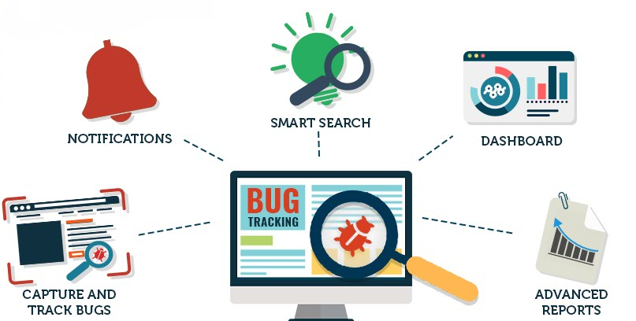

Fig.3.1: Service Incident Productivity Tracker

**2.2 Problem Statement:**

Generally, while doing any transactions or trying to access any results we may get failed response like server request failed or error response because of increased traffic in the website by the users. So the user cannot access the required response needed by the user. There by collecting all those failed requests, Effort tracker generates the possible incidents solved by the user within a particular time and the user can access the required responses in the future when needed.

**2.3 Project Objectives:**

* The main objective of service operation is to coordinate and carry out the activities and processes required to deliver and manage services at agreed levels to business users and customers.
* Facilitate rapid restoration of services following an unplanned service interruption.
* Recognize, record, classify, and report Incident data at the appropriate times Create a single documented process for all Incidents.
* Maintain a single repository for recording all Incidents.
* Ensure the process is adopted, adhered to, and escalated if there are compliance issues.

**2.4 Feasibility Study**

In this study, the man power needed and project duration is included.

**2.4.1 Man Power Needed**

This project doesn’t need greater man power. The goal of the project can be accomplished by very minimal man power, and with minimal cost.

**2.4.2 Project Duration**

The total duration to complete the project is 45 days provided the necessary equipment is given. This project mainly based on installing necessary software and writing appropriate code with the connection of the database. So more time is allocated to write the code and check whether there are any errors associated with it and improvement of the code.

**2.3 Advantages of proposed system**

* Higher efficiency and productivity throughout the organization
* Better end user satisfaction.
* Increased efficiency and productivity throughout the organization
* Meeting the requirement of IT service availability
* Valuable documentation of IT service management
* Continued high levels of service quality
* A better understanding of business requirements, resulting in better-fitting IT services
* Increased IT cost e­fficiency and value
* Reducing the business impact of incidents

**3. SYSTEM DESIGN**

**3.1 System Requirements**

The project is about how to resolve incidents which are raised by the clients when some problem arises while managing transactions, developing software.

**3.1.1 Hardware Requirements**

Processor : I3/Intel Processor

RAM : 4GB (min)

Hard Disk : 160GB

**3.1.2 Software Requirements**

Operating System : Windows 10

Application Server : Visual Studio

Front End : HTML, CSS, JQuery, AJAX, C#

Scripts : JavaScript

Database : Microsoft SQL Server Management Studio.

**3.2 Design using UML diagrams**

This chapter is concerned about physical module of the system a d the tools that are helpful in studying the physical module of the system. UML stands for Unified Modeling Language. UML is a standardized general-purpose modeling language in the field of object-oriented software engineering. The standard is managed, and was created by, the Object Management Group. The Unified Modeling Language is a standard language for specifying, Visualization, Constructing and documenting the artifacts of software system, as well as for business modeling and other non-software systems. The UML represents a collection of best engineering practices that have proven successful in the modeling of large and complex systems. The UML is a very important part of developing objects oriented software and the software development process. The UML uses mostly graphical notations to express the design of software projects.

**3.2.1 USE CASE DIAGRAM**

A use case diagram in the Unified Modeling Language (UML) is a type of behavioral diagram defined by and created from a Use-case analysis. Its purpose is to present a graphical overview of the functionality provided by a system in terms of actors, their goals (represented as use cases), and any dependencies between those use cases. The main purpose of a use case diagram is to show what system functions are performed for which actor. Roles of the actors in the system can be depicted. Use case describes the system from user’s point of view.

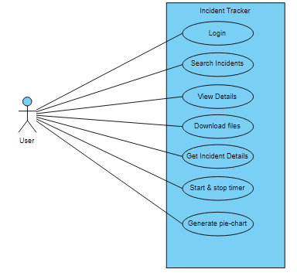

**3.2.2 CLASS DIAGRAM**

In software engineering, a class diagram in the Unified Modeling Language (UML) is a type of static structure diagram that describes the structure of a system by showing the system's classes, their attributes, operations (or methods), and the relationships among the classes. It explains which class contains information.

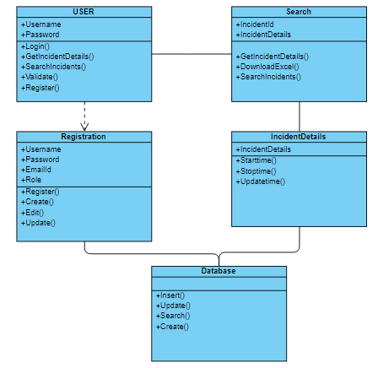

**3.2.3 SEQUENCE DIAGRAM**

A sequence diagram in Unified Modeling Language (UML) is a kind of interaction diagram that shows how processes operate with one another and in what order. It is a construct of a Message Sequence Chart. Sequence diagrams are sometimes called event diagrams, event scenarios, and timing diagrams.

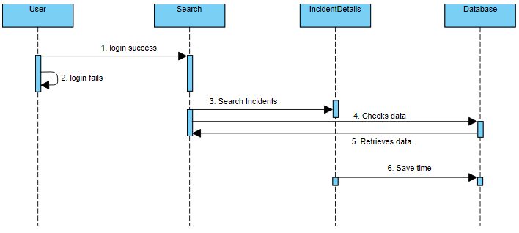

**3.2.4 ACTIVITY DIAGRAM:**

Activity diagrams are graphical representations of workflows of stepwise activities and actions with support for choice, iteration and concurrency. In the Unified Modeling Language, activity diagrams can be used to describe the business and operational step-by-step workflows of components in a system. An activity diagram shows the overall flow of control.

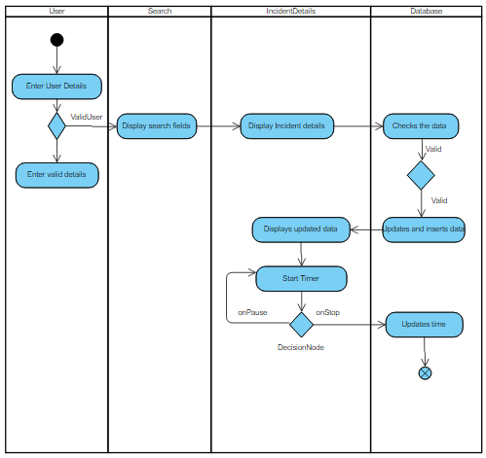

**3.3 Project Implementation Details**

The project implementation can be implemented using 3 modules as follows

**Modules:**

* **Login**
* **Search**
* **Incident**

**Login:**

The user logins in Effort Tracker if the login credentials of the user are valid. Then, it redirects to the search page. The user-session will start after the user login it will display the Logged-In username.

**Search:**

Here the functionality called export to excel is implemented. When clicked on export button, the excel sheet is downloaded consisting of all the incident details. When clicked on more details, it redirects to Pie-chart page based upon the logged-in user details it will generate the Pie-chart for the particular user such as Incidents the user had solved or left pending. The pending requests are continued from the place where they are left by the other user.

**Incident:**

Based upon Data given for Incident id, user name, Domain, Dates from one particular date to the other selected date the Details will be displayed. If the Particular Incident Id is clicked the Details such as Incident Id, time taken to solve the particular incident and Status whether it is closed or pending and the time spent by the user. In the Incident Module, the timer checks the time taken by the user to resolve the Incident. All these Details are updated are simultaneously in the Database.

### 4. Implementation

**4.1 Incident**

An incident is an unplanned interruption to or quality reduction of an IT service. Incidents differ from both problems and requests. An incident interrupts normal service; a problem is a condition identified through a series of multiple incidents with the same symptoms. Problem management resolves the root cause of the problem; incident management restores IT services to normal working levels. Requests for fulfillment are formal requests to provide something. These may include training, account credentials, transaction related issues, and anything else that the IT service desk offers. A request may need approvals before IT fulfills it. Incidents interrupt normal service, such as when a user’s computer breaks, when the VPN won’t connect. These are unplanned events that require help from the service provider to restore normal function

**4.1.1**. **Incident Management**

When most people think of IT, incident management is the process that typically comes to mind. It focuses solely on handling and escalating incidents as they occur to restore defined service levels. Incident management does not deal with root cause analysis or problem resolution. The main goal is to take user incidents from a reported stage to a closed stage. Once established, effective incident management provides recurring value for the business. It allows incidents to be resolved in timeframes previously unseen. The data gathered from tracking incidents allows for better problem management and business decisions. Incident management also involves creating incident models, which allow support staff to efficiently resolve recurring issues. Models allow support staff to resolve incidents quickly with defined processes for incident handling. In some organizations, a dedicated staff has incident management as their only role. Everyone has issues they need support or facilities staff to resolve, and handling them quickly aligns with the needs of users at all levels. Operational incident management requires several key pieces:

1.Incident models, or templates, that allow incidents to be resolved efficiently.

2.Categorization of incident types for better data gathering and problem management.

3.Agreement on incident statuses, categories, and priorities

4.Establishment of a major incident response process

5.Agreement on incident management role assignment

**4.1.2 The Incident Process**

Incidents go through a structured workflow that encourages efficiency and best results for both providers and customers. The incident management process follows these steps:

* Incident identification
* Incident logging
* Incident categorization
* Incident response
* Investigation and diagnosis
* Resolution and recovery
* Incident closure

The incident process provides efficient incident handling, which in turn ensures continual service uptime  
The first step in the life of an incident is **incident identification**. Incidents come from users in whatever forms the organization allows. Requests are categorized and handled differently than incidents, and they fall under request fulfillment.

**Incident logging:** By entering the valid credentials - username and password, the user enters into the site.

**Incident categorization:** Once identified as an incident, the service desk logs the incident as a ticket. The ticket should include information, such as the user’s name and contact information, the incident description, and the date and time of the incident report Incident categorization is a vital step in the incident management process. Categorization involves assigning a category and at least one subcategory to the incident. This action serves several purposes. Once identified, categorized, and logged, the service desk can handle and resolve the incident. Incident resolution involves these steps:

**Incident Response:** The response of the solved ticket is shown in the form of the pie-chart. By using timer, the incident is started and the time is shown. After the issue had been cleared the timer is stopped. Once for every five minutes the timer is updated and the pop-up box is displayed. The details are updated in the database whenever the problem is solved.

**Investigation and diagnosis**: These processes take place during troubleshooting when the initial incident hypothesis is confirmed as being correct. Once the incident is diagnosed, staff can apply a solution, such as changing software settings, applying a software patch, or ordering new hardware.

**Resolution and recovery**: This is when the service desk confirms that the user’s service has been restored to the required level.

**Incident closure**: At this point, the incident is considered closed and the incident process ends.

**4.1.3 Incident Status:**

* On hold or pending
* Opened
* Closed

The **on-hold** status indicates that the incident requires some information or response from the user or from a third party. The incident is placed “on hold” so that response deadlines are not exceeded while waiting for a response from the user or vendor.

The **opened**status means that the service desk is working on the incident by using timers.  
The **closed**status indicates that the incident is resolved and that no further actions can be taken. Incident management follows incidents through the service desk to track trends in incident categories and time in each status. The final component of incident management is the evaluation of the data gathered. Incident data guides organizations to make decisions that improve the quality of service delivered and decrease the overall volume of incidents reported. Incident management is just one process in the service operation framework

**4.2 Database Creation:**

For the ticket details, the values are stored in the database by using the appropriate tables. The login details are stored in the Test user table to check whether the credentials are valid. If new user wants to register, the details are entered and updated in the database. The Incident details are stored in the Incident details table. In Incident Details table, the information such as the group they are assigned to, date related details, status of the ticket and short description of the ticket is shown. For the details to be added a stored procedure is written in the database.

**5.CODE ANALYSIS**

Code consists of five controllers in **Asp.net mvc** namely –

* Home Controller
* Index Controller
* Login Controller
* Register Controller
* Search Controller

**Home Controller** consists of Index view, Contact view and About view. In the user model password and username is declared mandatory. When details are entered here, it displays the Login.

In **Login Controller** there are Edit View, Error View, get details of user view and Save role view. Here the details of the user can be edited. All the user details are displayed and if any error occurs it displays the error view.

In **Register controller** there is register view. All the details of the register are stored in this view and are displayed.

In **Search Controller** there are Search view, save time view, save details view, Incident details view, get all domains view and Details grid view. In the search view the details of the incident such as number, assigned group, Status can be searched here. In the save details view the details are saved. For the usage of timer save time view is implemented. The details of the timer are saved in this view along with the start time and the end time. Details grid view is a partial view in which are the incident details are displayed according to the details searched.

In **Asp.net web api** there are four controllers namely-

* Home Controller
* User Controller
* Incident Controller
* Values Controller

In **Incident Controller** the methods for incidents are implemented. These methods are helpful to function the incident mvc as a back process. The methods for all the details of the search such as get all domains, get all status, get all ids, assigned dates are written here. If the incident had not been solved in a particular time, the method called update time is implemented. The back-end process of search called query search methods are implemented.

In **User Controller** the method for paging is implemented. The paging is used to display the incident details in a particular way. The paging helps to count the number of incidents and allocates them in an ordered way.

**6.RESULTS**

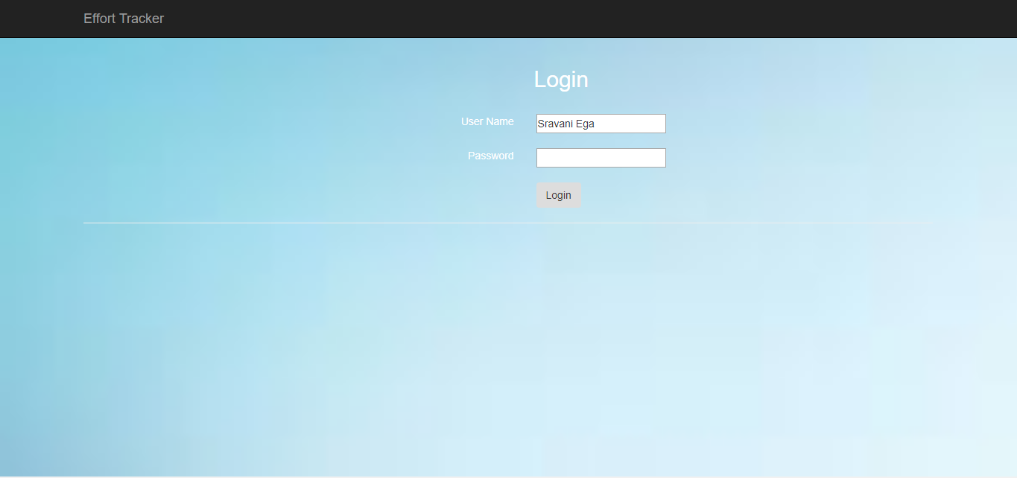

Fig.6.1 login page

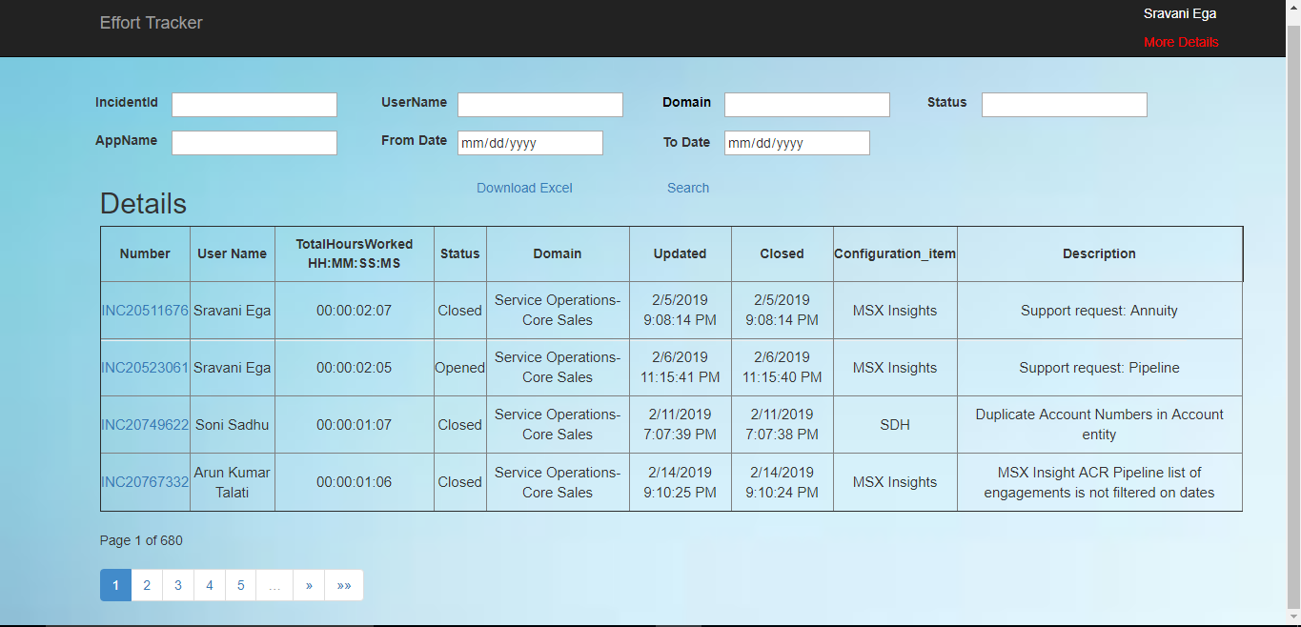

Fig.6.2 Entered credentials are valid.

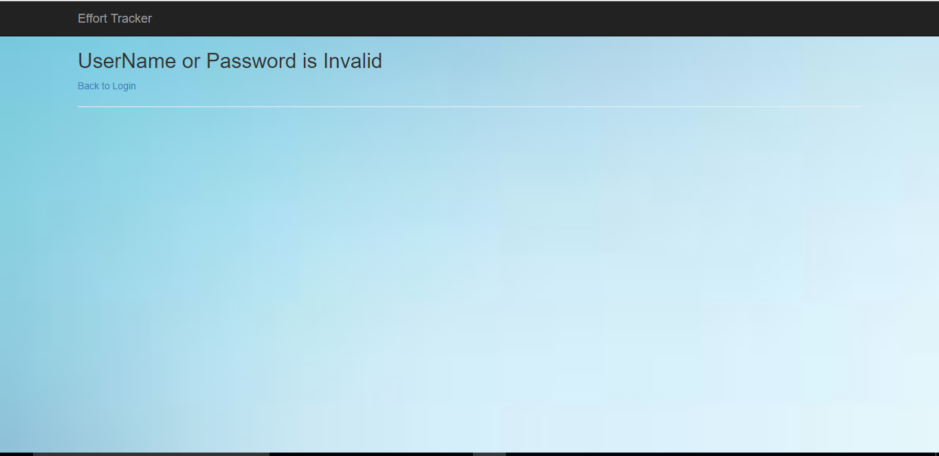

Fig.6.2 If Invalid credentials

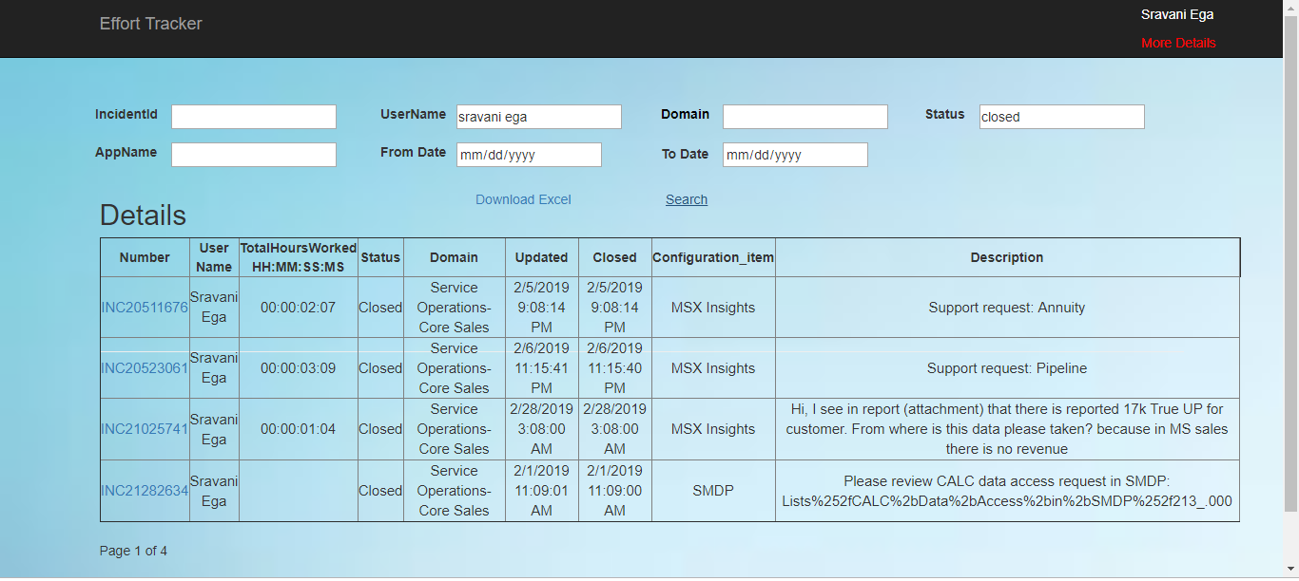Fig.6.4 The Search Details

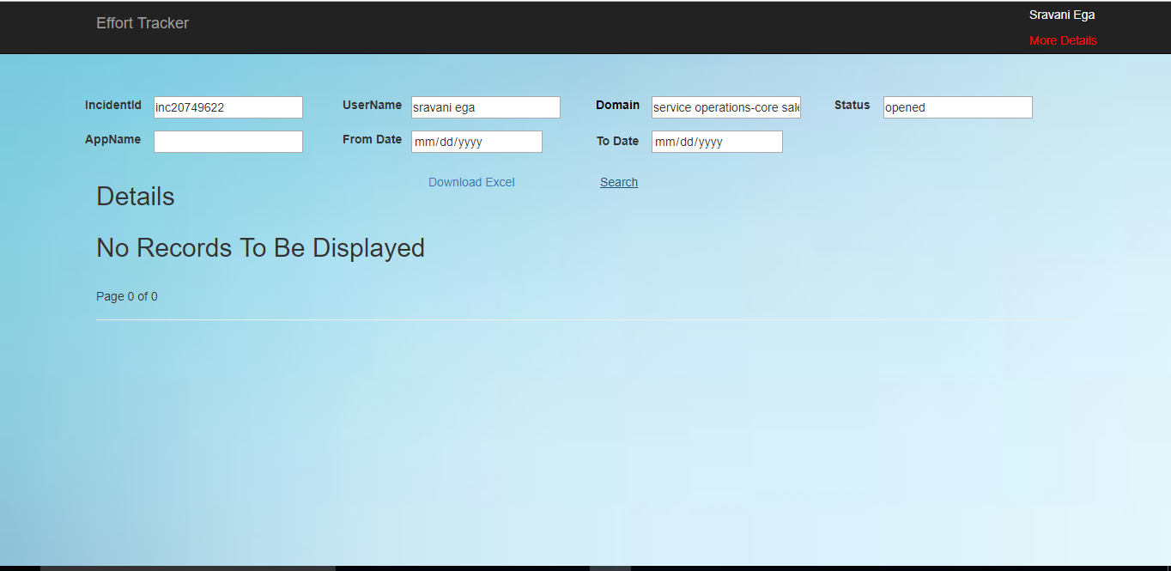

Fig.6.5 When Incident details in the drop downs are mismatched.

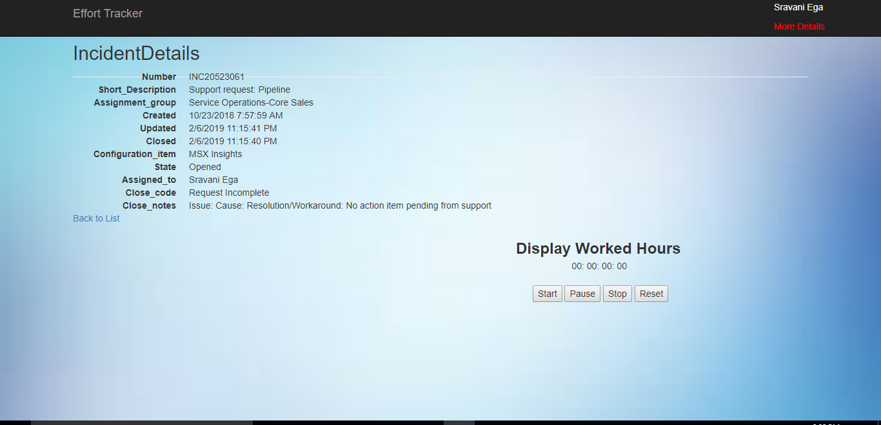

Fig.6.6 Hyperlink of IncidentId in grid.

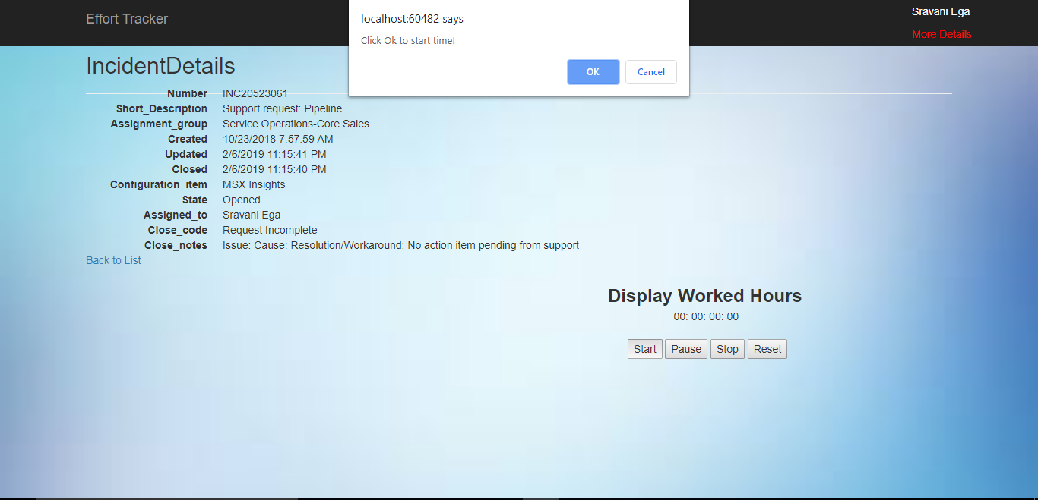

Fig.6.7 When Timer is set on, in the Incident Details page

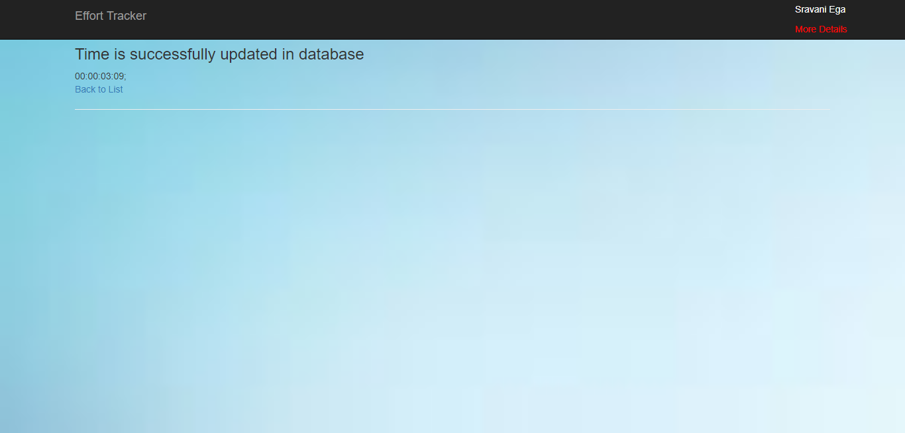

Fig.6.8 When Ticket is in opened state

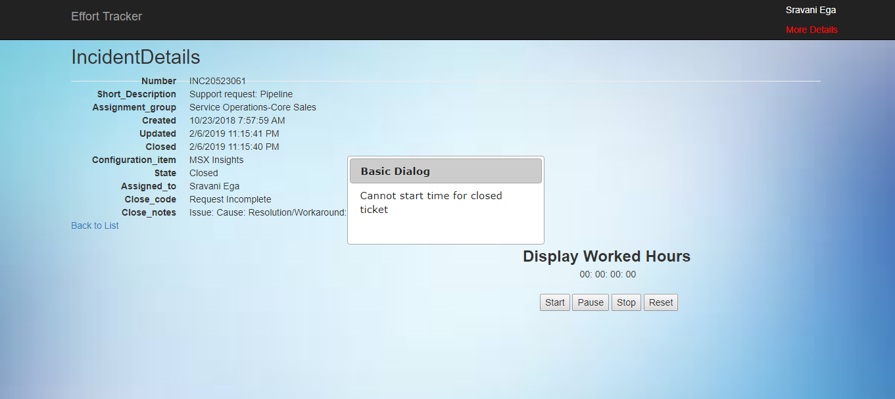 Fig.6.9 When the Ticket is closed.

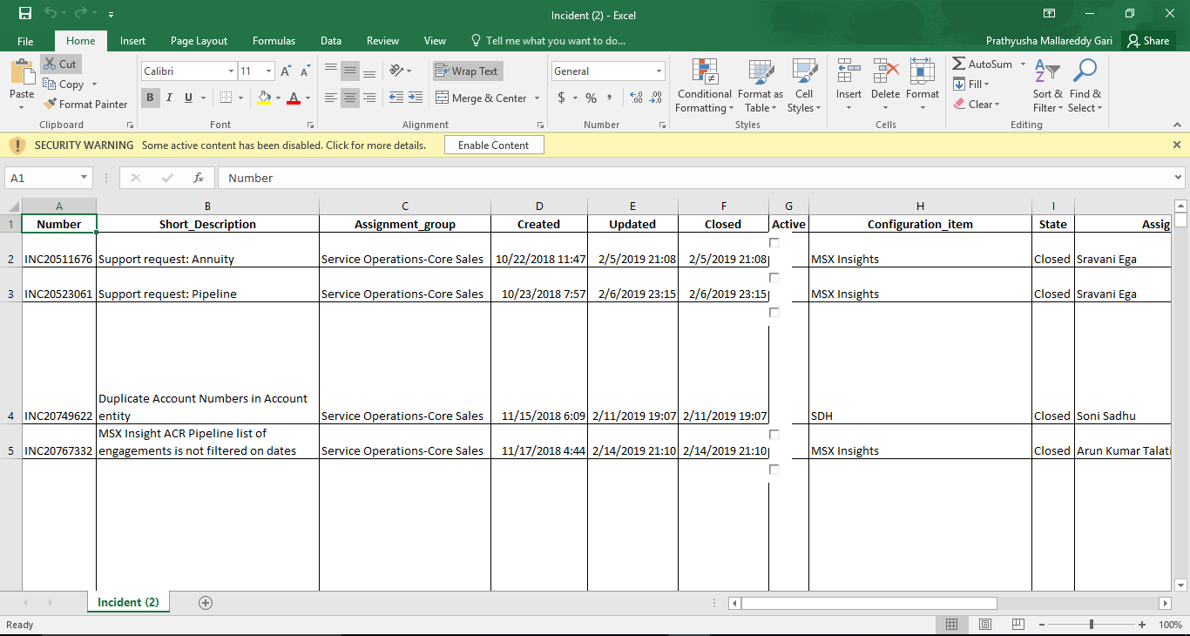

Fig.6.10 When download to excel button is pressed in the search details page

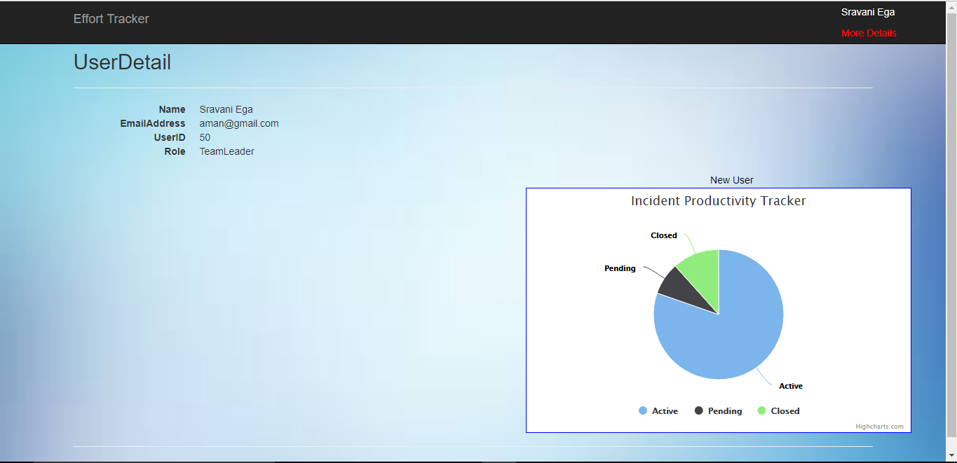

Fig.6.11 When more details are pressed in the search details page

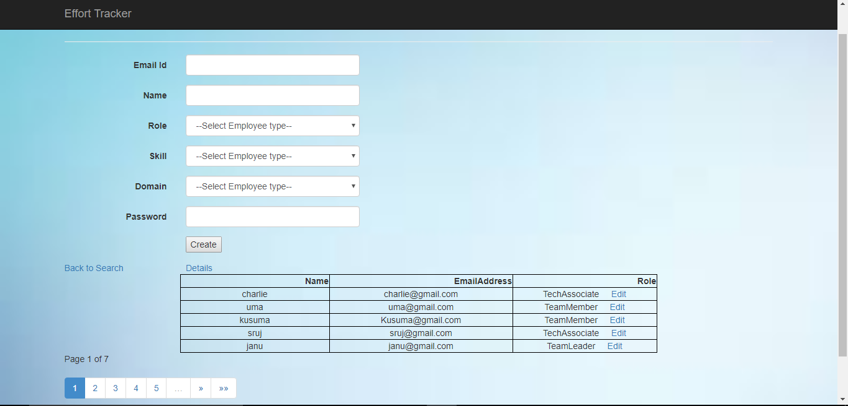

Fig.6.12 When new user button is pressed in the above page

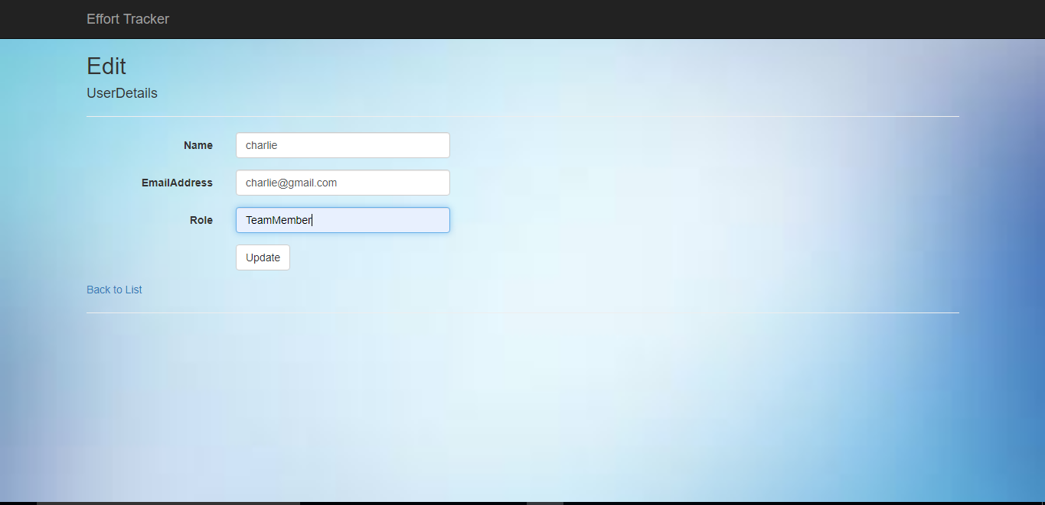

Fig.6.13 When edit button is clicked; it is navigated to updated page



Fig.6.14 When details are updated successfully.

**7. Conclusion**

Incident management follows incidents through the service desk to track trends in incident categories and time in each status. The final component of incident management is the evaluation of the data gathered. Incident data guides organizations to make decisions that improve the quality of service delivered and decrease the overall volume of incidents reported. Employee productivity has a direct impact on your business revenue, so high productivity is essential for your company’s success. There are many reasons for low employee performance, but using innovative methods for monitoring worker activity will let you reveal problems with productivity in the workplace and eliminate them effectively.